Name:___________________________________________ Period:__________
Unit 3 REVIEW
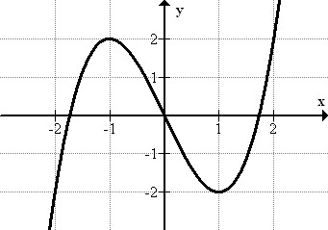
Use the graph below for questions 1 & 2.

1) Is the relation a function? Why or why not?
- The relation is not a function because it passes through the x-axis twice.
- The relation is not a function because it passes through the y-axis twice.
- The relation is a function because it passes through the x-axis only once.
- The relation is a function because it passes through the y-axis only once.

2) Identify the domain and range of the above graph. Select two answers, one from each group.
Domain
(select one)
Range
(select one)
- $[-2, 2]$ D. $[-6,∞)$
- $(-∞,∞)$ E. $[-2, 2]$
- $[-6,∞)$ F. $(-∞,∞)$

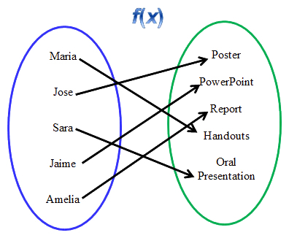
3) The first set of data are students names, the second set is the type of project they are completing. Is the relation that maps the student to the project type a function? Justify your answer.

4) The WCHS AP Physics class launches potatoes off the roof of the school. The function
$h\left(t\right)=-16t^{2}+32t+150$ describes the height, in feet, of the potato $t$ seconds after it is thrown.
What is the height of the potato, in feet, 3 seconds after it is launched?

__________ feet

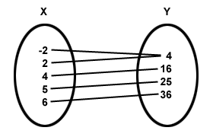
5) Select the three functions.

- {(3, 5) , (4, 5), (-2, 5) , (3, 4)| C)

X | Y
-2 | 5
0 | 5
2 | 9
4 | 0

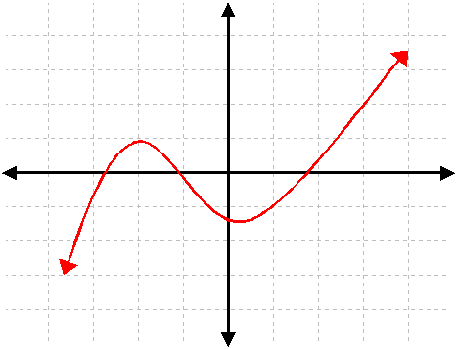
- D)

X | Y
3 | 1
3 | 2
3 | 6
3 | 9

E)

6) Given the functions $f\left(x\right), g\left(x\right),$ and $h\left(x\right).$
$g\left(x\right)=2x^{2}-4x+5$ $h\left(x\right)=3.5(1.25)^{x}$ $f\left(x\right)=-\frac{1}{4}x+8$
Order the functions from least to greatest when evaluated for $x=4$.

7) What are the range values of the function g(x) = |3x| - 2 given the domain values {-2, 0, 5}?

8) Which ordered pair is not on the graph of the equation$y=3^{x}$?
A) (0, 1) C) (1, 3)
B) (2, 6) D) (3, 27)

9) Identify THREE points that are solutions to the function graphed?

10) The function S(t) gives the Sales at a haunted house of the number of, t, tickets. What is a reasonable domain for S(t)
A. The real numbers B. The nonnegative real numbers
C. The nonnegative integers D. The nonnegative rational numbers

11) Ms. Kohrt was given the function y = 0.5x² – 2 and sketched its graph. Her student, Emelia stated that the point (-2, 0) was a solution to the equation. Do you agree with Emelia? Justify your answer.
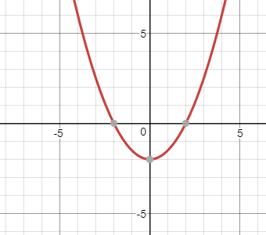

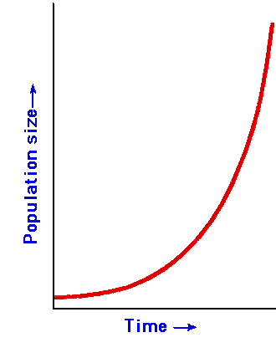
12) The following graph shows the population or a neighborhood over time. The initial population of the neighborhood was 10 people. What is the domain of the function and what does it represent in this context?

13) Niagara Falls is slowly eroding. The height $h$, in feet, of the falls, $t$ hours after it is formed is given by the function $h\left(t\right)=240-0.005t$. Which of the following would best describe the domain of this function?

- All nonnegative real numbers.
- All nonnegative integers.
- All nonnegative real numbers less than or equal to 240.
- All nonnegative real numbers less than or equal to 48000.

14) Cecelia wanted to be more self-sustaining so she planted a garden in her backyard. She planted a tomato vine that was originally 6 inches tall. The tomato vine’s growth, in feet, each week can be modeled by the equation f(x) = .25x + 6, where x is the number of weeks. The vine is expected to reach full height when it is 12 weeks old.
Determine a reasonable domain for the context.

Domain: _____ $≤x≤$ ________

15) Mrs. Mucha went skydiving. When she jumped out of the plane her path can be modeled by the function
M(t) = 10,500 – 250t, where t is in seconds and M(t) is in feet.

What is the domain of the function within the context?
0 $≤t≤$ ____

